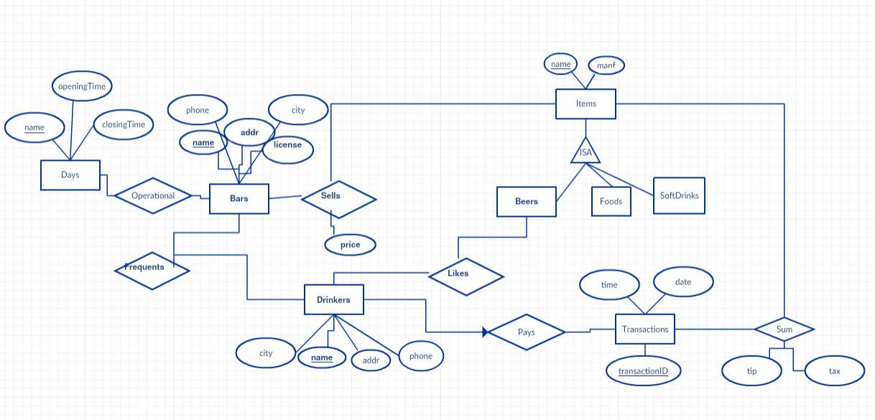

id

\*

1..\*

1

7

\*

\*

\*

1

\*

\*

0…\*

1

0…\*

1…\*

address

state

close

open

address

state

pretotalSum

tip

has

ㅗㅁㅍ

type

totalSum

day

day

operational

days

occurs